1. **Read multiple JSON files into a directory to convert into a dataset.**

**I have files text1, text2, text3 in the directory JSON**

**Ans:**

**Read the JSON File**

The JSON file is read by R using the function from **JSON()**. It is stored as a list in R.

# Load the package required to read JSON files.

library("rjson")

# Give the input file name to the function.

result <- fromJSON(file = "input.json")

# Print the result.

print(result)

When we execute the above code, it produces the following result −

$ID

[1] "1" "2" "3" "4" "5" "6" "7" "8"

$Name

[1] "Rick" "Dan" "Michelle" "Ryan" "Gary" "Nina" "Simon" "Guru"

$Salary

[1] "623.3" "515.2" "611" "729" "843.25" "578" "632.8" "722.5"

$StartDate

[1] "1/1/2012" "9/23/2013" "11/15/2014" "5/11/2014" "3/27/2015" "5/21/2013"

"7/30/2013" "6/17/2014"

$Dept

[1] "IT" "Operations" "IT" "HR" "Finance" "IT"

"Operations" "Finance"

**Convert JSON to a Data Frame**

We can convert the extracted data above to a R data frame for further analysis using the **as.data.frame()** function.

# Load the package required to read JSON files.

library("rjson")

# Give the input file name to the function.

result <- fromJSON(file = "input.json")

# Convert JSON file to a data frame.

json_data_frame <- as.data.frame(result)

print(json_data_frame)

When we execute the above code, it produces the following result −

id, name, salary, start_date, dept

1 1 Rick 623.30 2012-01-01 IT

2 2 Dan 515.20 2013-09-23 Operations

3 3 Michelle 611.00 2014-11-15 IT

4 4 Ryan 729.00 2014-05-11 HR

5 NA Gary 843.25 2015-03-27 Finance

6 6 Nina 578.00 2013-05-21 IT

7 7 Simon 632.80 2013-07-30 Operations

8 8 Guru 722.50 2014-06-17 Finance

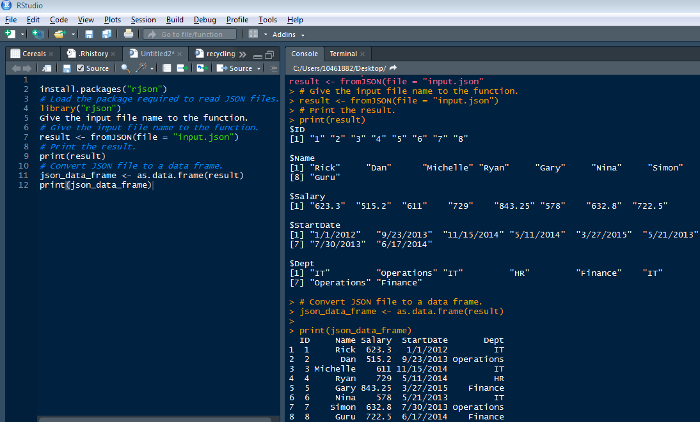

1. **Parse the following JSON into a data frame.**

**js<-'{  
"name": null, "release_date_local": null, "title": "3 (2011)",  
"opening_weekend_take": 1234, "year": 2011,  
"release_date_wide": "2011-09-16", "gross": 59954  
}'**

**Ans:**

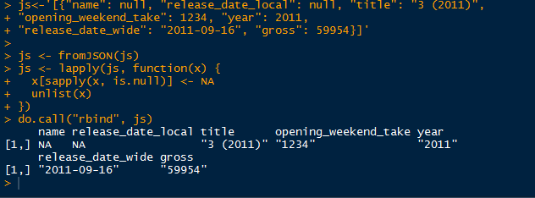

1. **Write a script for Variable Binning using R.**

**Ans:**

